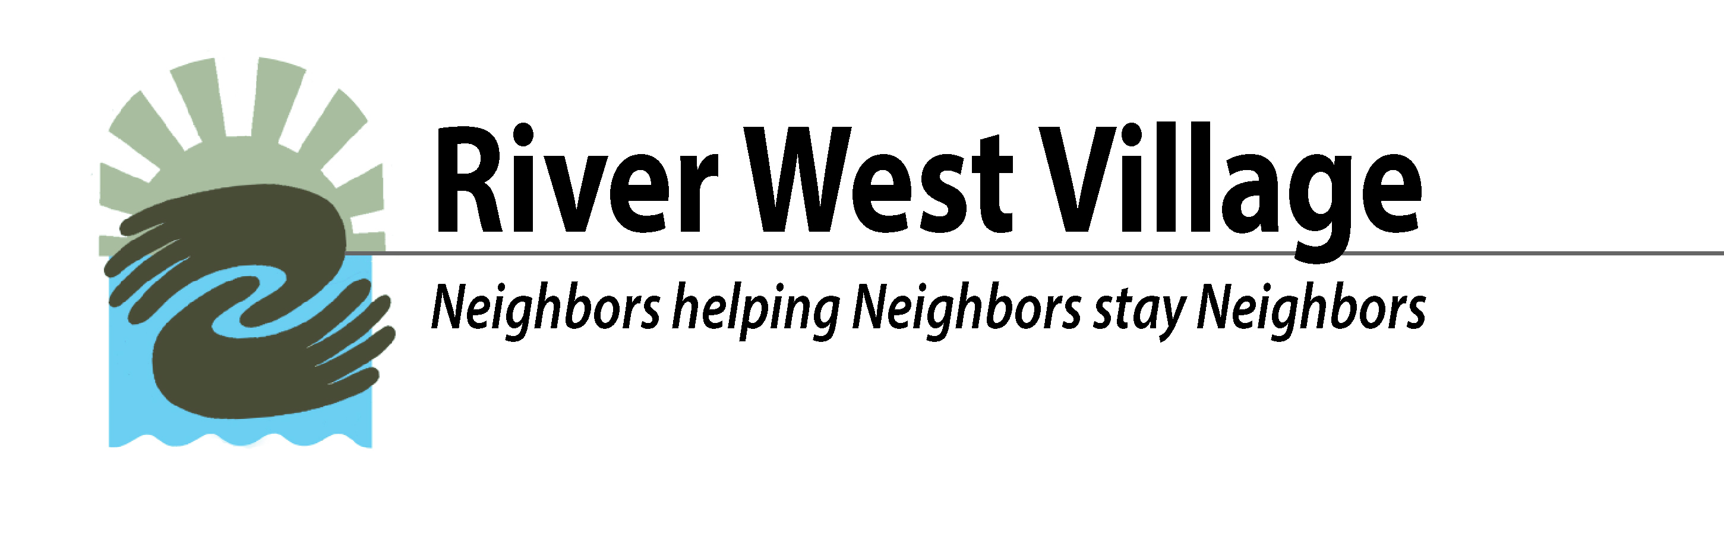
Thank you for joining us as we prepare to launch River West Village October 1, 2017!

Please provide your contact information and indicate your interests.

Check all that are applicable:
___ I am interested in RWV membership. ___ Full-Service Membership ___ Social Membership
___ I need more information. Preferred method of contact: ___ E-mail ___Phone ___Text
___ I am interested becoming a Founding Member (Donation of $500 or more in addition to member fees)

Name_______________________________________________ Phone number____________

Street Address_________________________________________________________________
city zip code

E-Mail Address________________________________________

We will be in touch with you soon! Thank you for your interest.
The River West Village Membership Team

Thank you for joining us as we prepare to launch River West Village October 1, 2017!

Please provide your contact information and indicate your interests.

Check all that are applicable:
___ I am interested in RWV membership. ___ Full-Service Membership ___ Social Membership
___ I need more information. Preferred method of contact: ___ E-mail ___Phone ___Text
___ I am interested becoming a Founding Member (Donation of $500 or more in addition to member fees)

Name_______________________________________________ Phone number____________

Street Address_________________________________________________________________
city zip code

E-Mail Address________________________________________

We will be in touch with you soon! Thank you for your interest.
The River West Village Membership Team

